Experiment 1

Basic File and User Management Commands

Aim
To execute and understand the usage of rm, users, and tree commands in Kali Linux.

Theory

rm Command
The rm command is used to remove files and directories from the Linux file system.

Syntax:
rm filename
Example:
touch test.txt
rm test.txt

Users Command
Displays the usernames of users currently logged into the system.
Syntax:
Users

tree Command
Displays directories and files in a tree-like structure.
Syntax:
Tree

Procedure
- Open Kali Linux Terminal.
- Create a sample file.
- Execute the rm command.
- Execute the users command.
- Execute the tree command.

Sample Output
kali@kali:~$ users
kali
kali@kali:~$ tree
.
├── Documents
├── Downloads
└── Desktop

Output:

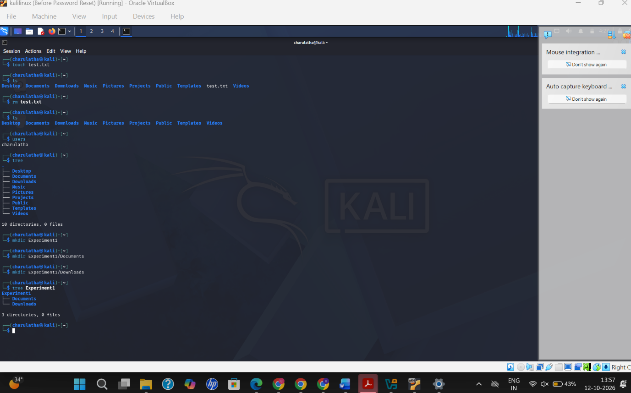

Result
Successfully executed rm, users, and tree commands in Kali Linux.

